Home Assignment 1:
LangChain Model Switching
Phase 1:
Prompt:
Follow the instructions in the attached file langchain_model_switching_final_prompt.md exactly.

Start with Phase 1 only: inspect this repository, trace the current Groq-based flow, and give me the discovery report and plan.

Do not write code, install packages, or edit any file. Stop after the report and wait for my approval before Phase 2.

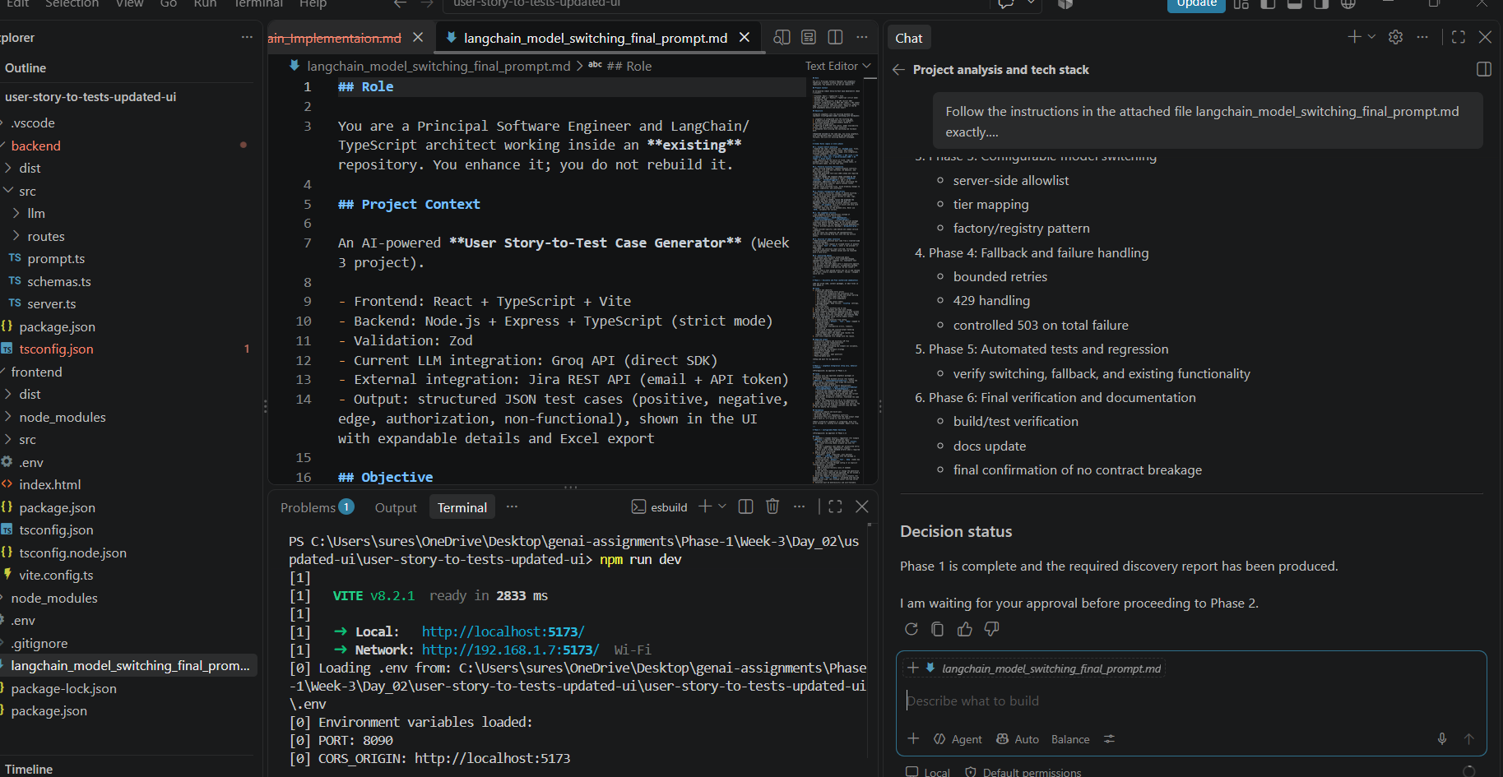
Phase 2:
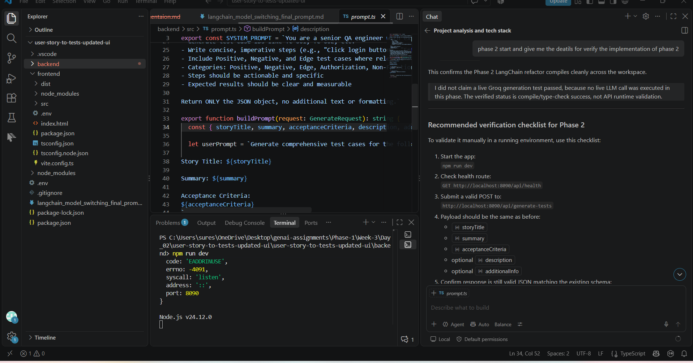
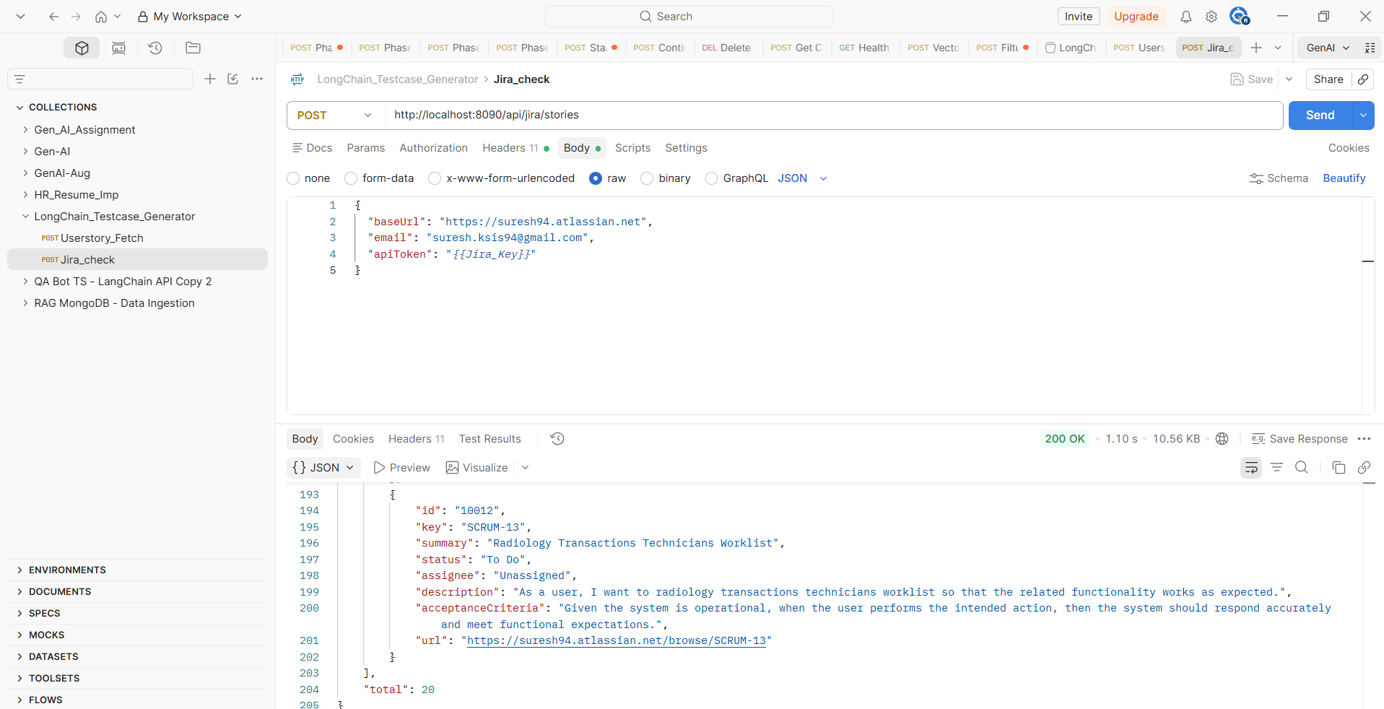
Phase 3:
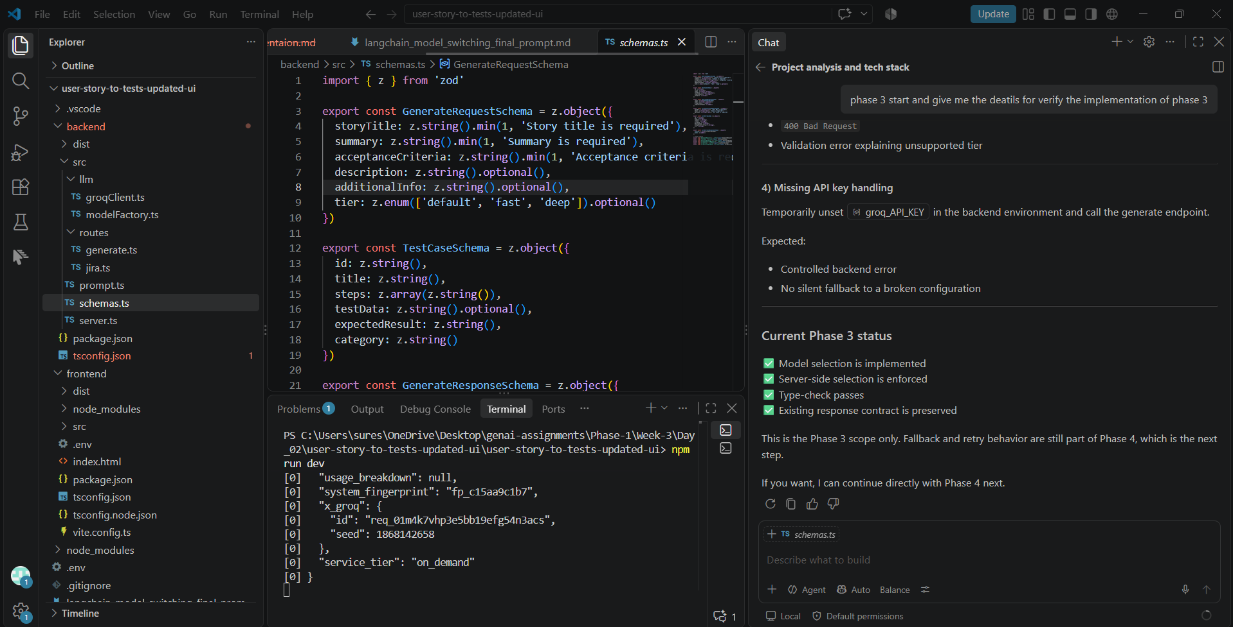
Phase 4:
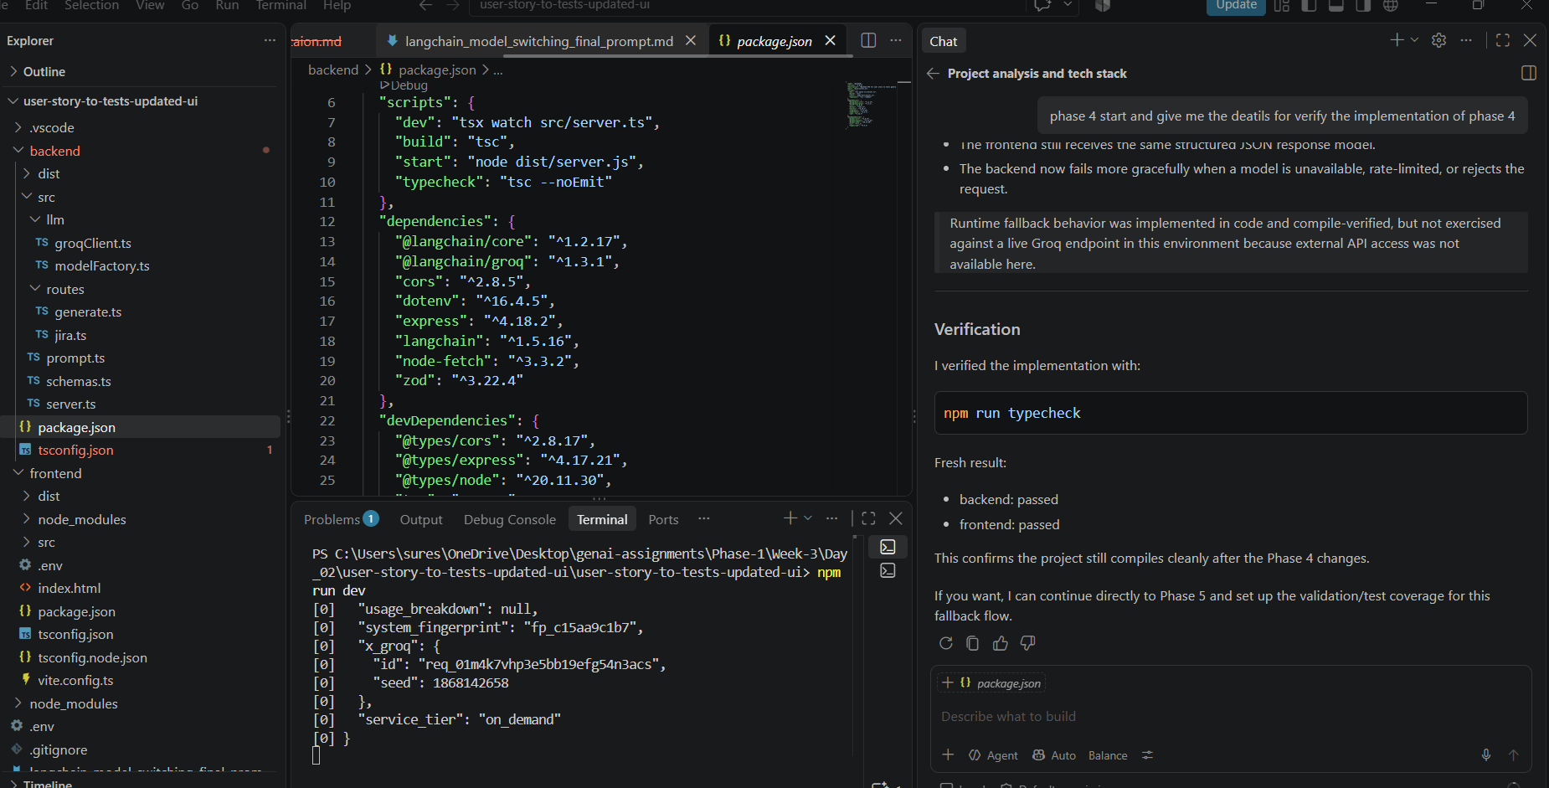
Phase 5:
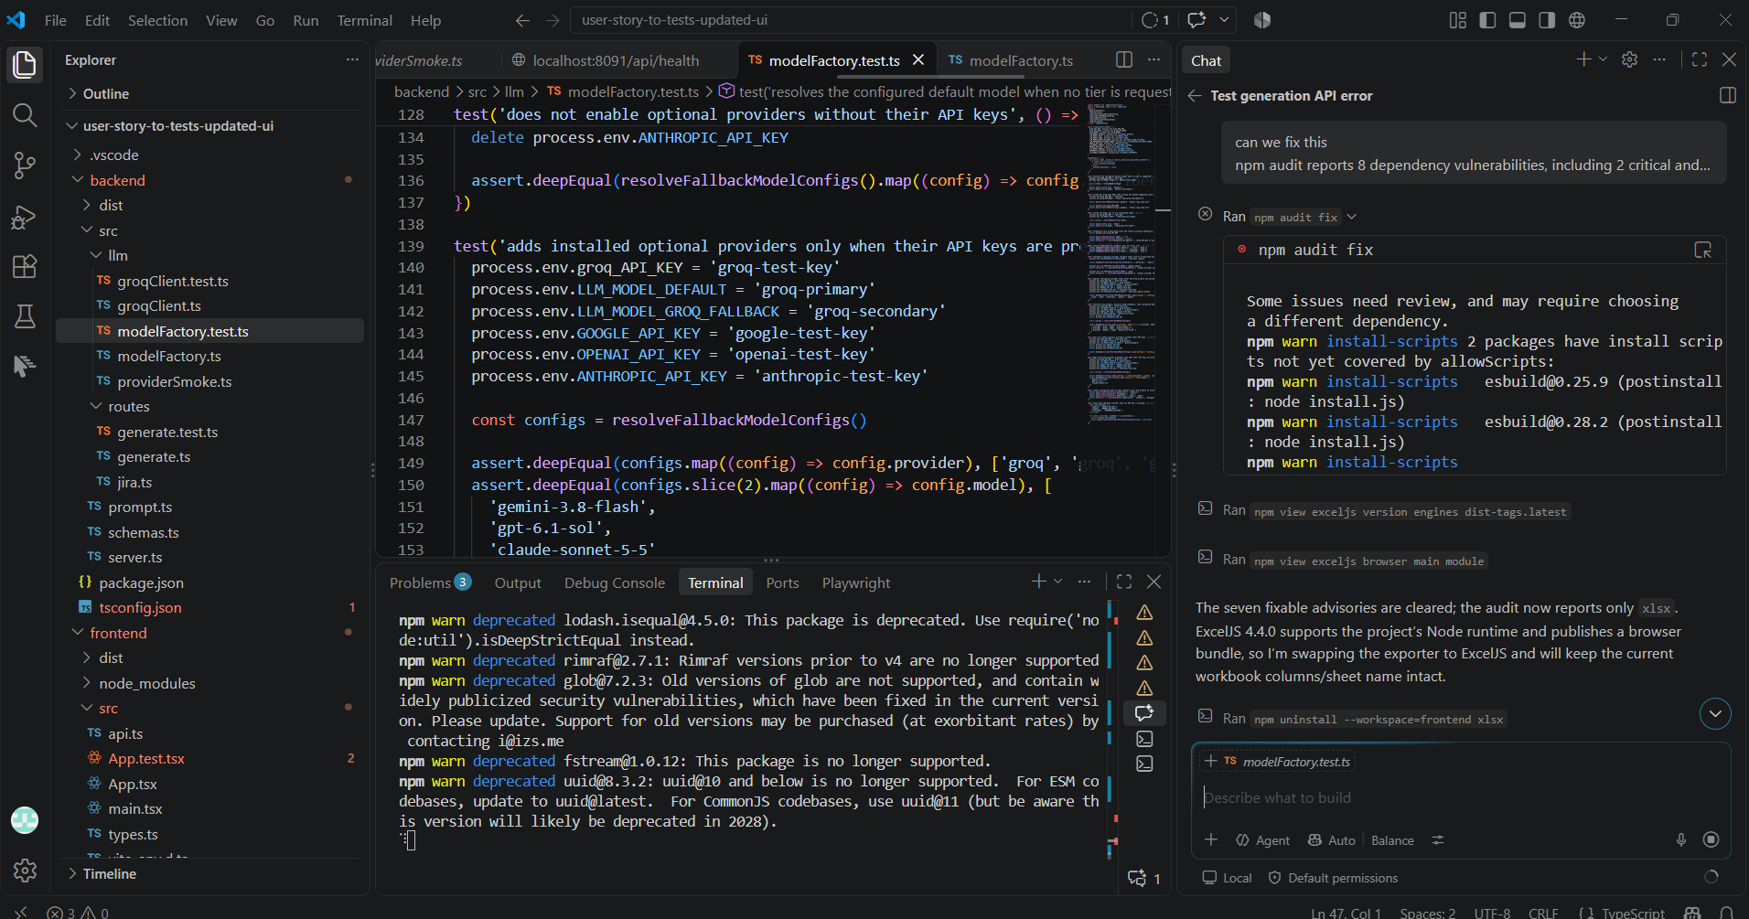

Fall back implementation when groq fail: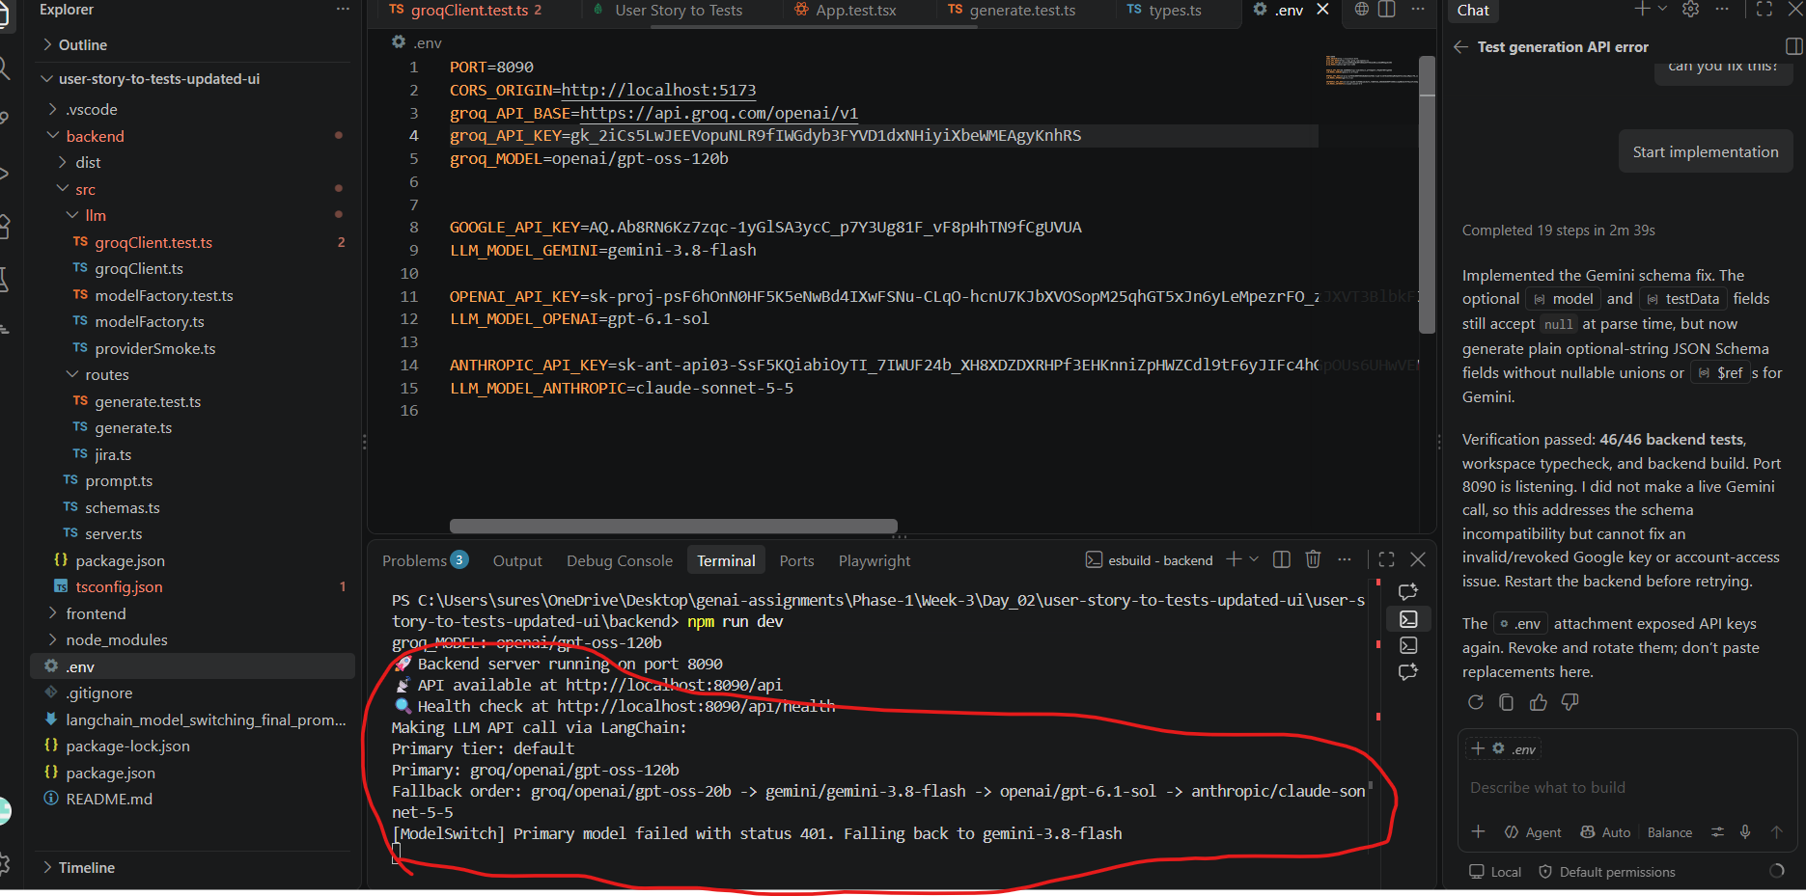
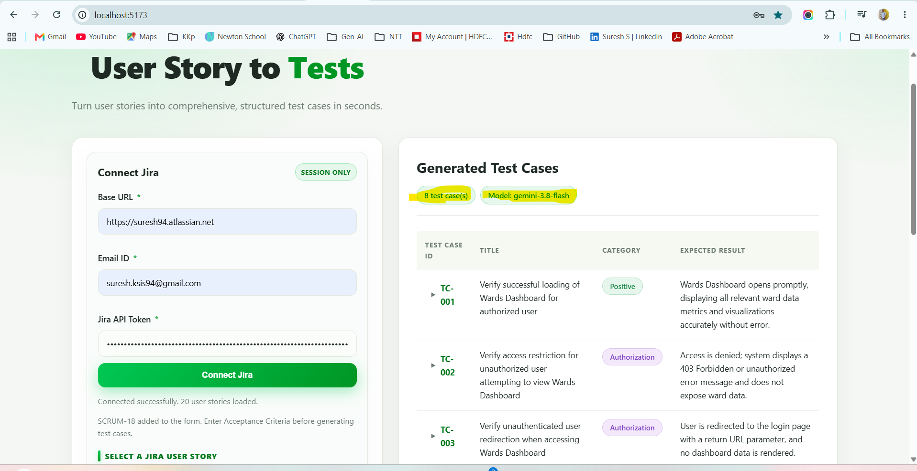
When Groq is available :
